**Space exploration**, the investigation, by means of crewed and uncrewed [spacecraft](https://www.britannica.com/technology/spacecraft), of the reaches of the [universe](https://www.britannica.com/science/universe) beyond [Earth](https://www.britannica.com/place/Earth)’s atmosphere and the use of the information so gained to increase knowledge of the [cosmos](https://www.britannica.com/science/Cosmos-astronomy) and benefit humanity. A complete list of all crewed spaceflights, with details on each mission’s accomplishments and crew, is available in the section [Chronology of crewed spaceflights](https://www.britannica.com/science/space-exploration/Chronology-of-crewed-spaceflights#ref286805).

[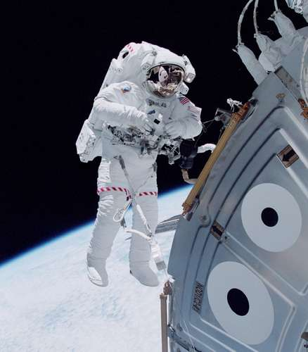](https://cdn.britannica.com/06/72006-050-5EF22ECB/Michael-Lopez-Alegria-space-module-station-assembly-International-October-2000.jpg)

U.S. space shuttle astronaut Michael Lopez-Alegria floating in space outside the Unity module of the International Space Station in October 2000, during an early stage of the station's assembly in Earth orbit.*NASA*

Humans have always looked at the heavens and wondered about the nature of the objects seen in the night sky. With the development of [rockets](https://www.britannica.com/technology/rocket-jet-propulsion-device-and-vehicle) and the advances in electronics and other technologies in the 20th century, it became possible to send machines and [animals](https://www.britannica.com/animal/animal) and then people above Earth’s [atmosphere](https://www.britannica.com/science/atmosphere) into outer [space](https://www.britannica.com/science/space-physics-and-metaphysics). Well before technology made these achievements possible, however, space exploration had already captured the minds of many people, not only aircraft pilots and scientists but also writers and artists. The strong hold that space travel has always had on the imagination may well explain why professional astronauts and laypeople alike consent at their great peril, in the words of [Tom Wolfe](https://www.britannica.com/biography/Tom-Wolfe) in *The Right Stuff* (1979), to sit “on top of an enormous Roman candle, such as a Redstone, [Atlas](https://www.britannica.com/technology/Atlas-American-launch-vehicles), [Titan](https://www.britannica.com/technology/Titan-rocket) or [Saturn](https://www.britannica.com/technology/Saturn-launch-vehicle) [rocket](https://www.britannica.com/technology/rocket-jet-propulsion-device-and-vehicle), and wait for someone to light the fuse.” It perhaps also explains why space exploration has been a common and enduring theme in [literature](https://www.britannica.com/art/literature) and art. As centuries of speculative [fiction](https://www.britannica.com/art/fiction-literature) in books and more recently in films make clear, “one small step for [a] man, one giant leap for mankind” was taken by the human spirit many times and in many ways before [Neil Armstrong](https://www.britannica.com/biography/Neil-Armstrong) stamped humankind’s first footprint on the [Moon](https://www.britannica.com/science/moon-natural-satellite).

[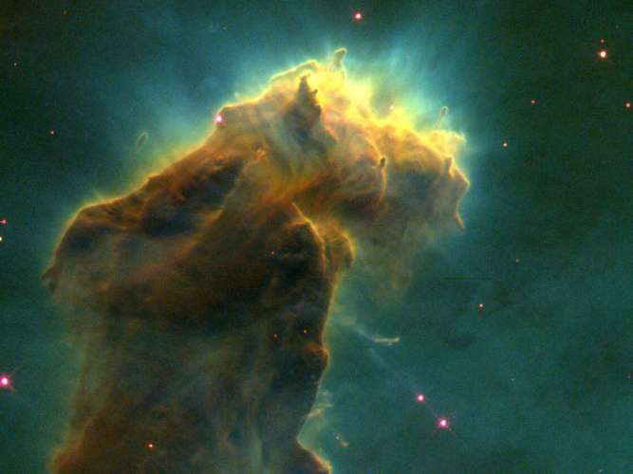](https://cdn.britannica.com/60/21260-120-21654CD7/nursery-Eagle-Nebula-detail-image-column-stars.jpg)

A stellar nursery in the Eagle Nebula (M16, NGC 6611). This detail of a composite image taken by the Earth-orbiting Hubble Space Telescope reveals a glowing column of dust and cold gas populated by embryonic stars forming from molecular hydrogen within the column.*NASA, ESA, STScI, J. Hester and P. Scowen (Arizona State University)*

Achieving spaceflight enabled humans to begin to explore the solar system and the rest of the universe, to understand the many objects and phenomena that are better observed from a space perspective, and to use for human benefit the resources and attributes of the space [environment](https://www.britannica.com/science/environment). All of these activities—discovery, scientific understanding, and the application of that understanding to serve human purposes—are elements of [space exploration](https://www.britannica.com/science/space-exploration). (For a general discussion of [spacecraft](https://www.britannica.com/technology/spacecraft), launch considerations, flight trajectories, and [navigation](https://www.britannica.com/technology/navigation-technology), docking, and recovery procedures, *see* [spaceflight](https://www.britannica.com/science/spaceflight).)